WEB SECURITY REPORT

SQL Injection Vulnerabilities

Prepared by: Mammadov Rustam
Platform: PortSwigger Web Security Academy

May 2,2026

INTRODUCTION:

1.1. Purpose of the Report

This report presents the practical solutions and analysis of laboratory tasks from the SQL Injection section of the PortSwigger Web Security Academy. The primary objective is to identify how vulnerabilities in database query structures can lead to unauthorized data exposure, specifically focusing on UNION-based attacks to retrieve system information.

1.2. Software Used

1.Burp Suite Community Edition (For request analysis)
2.Mozilla Firefox (Web browser)
3.FoxyProxy Standard (For proxy management)

1.3. Summary of Findings

During the tests conducted, it was discovered that the application's product category filter is vulnerable to UNION-based SQL Injection. By manipulating the database queries, it was possible to bypass application logic and extract sensitive information from the database server, including its exact version and type (Oracle, MySQL, etc.).

Lab #1 - SQL injection vulnerability in WHERE clause allowing retrieval of hidden data

2.1. Laboratory Information

In this laboratory task, it was determined that the application's product category filter is vulnerable to SQL injection. The objective is to manipulate the SQL query in the WHERE clause to bypass application logic. By injecting a boolean condition that is always true (e.g., ' OR 1=1--), it is possible to retrieve and display hidden data—such as unreleased products—that are not normally visible to users.

2.2. Solution Steps
Step 1: Request Interception Access the application, select a product category filter, and intercept the resulting GET /filter?category=[category] request using Burp Suite. Send the request to Repeater.
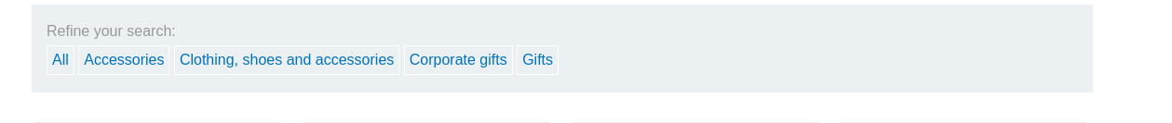
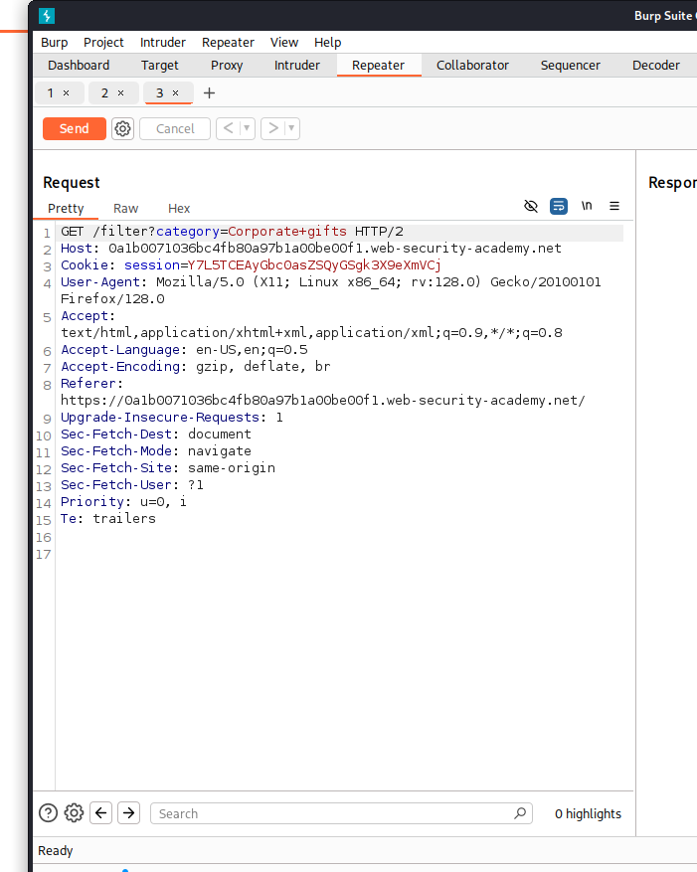

Step 2: Vulnerability Testing Append a single quote (') to the category parameter and send the request. Observe the server's response for any database errors or structural changes to confirm SQL injection vulnerability.

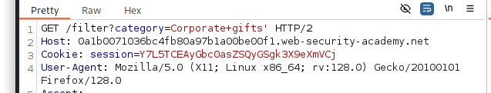

Step 3: Logical Bypass Injection Inject the following payload into the category parameter to manipulate the query logic and bypass the hidden product filter: ' OR 1=1—

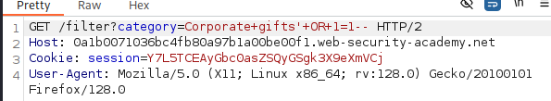

Step 4: Execution and Data Verification Submit the modified request. Verify that the application displays all products, including unreleased items, confirming the successful retrieval of hidden data.

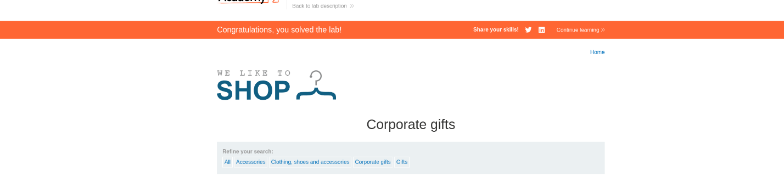

Lab#2 - SQL injection vulnerability allowing login bypass

3.1. Laboratory Information

The application's login form fails to sanitize user input before incorporating it into a database query. This vulnerability allows an attacker to manipulate the SQL logic, effectively disabling the password verification requirement and gaining unauthorized access to any account.

3.2. Solution Steps

Step 1: Analyzing the Login Request Navigate to the login page (/login). Enter arbitrary values into the username and password fields and click "Log in." Use Burp Suite to intercept the POST /login request and send it to the Repeater tab for further testing.

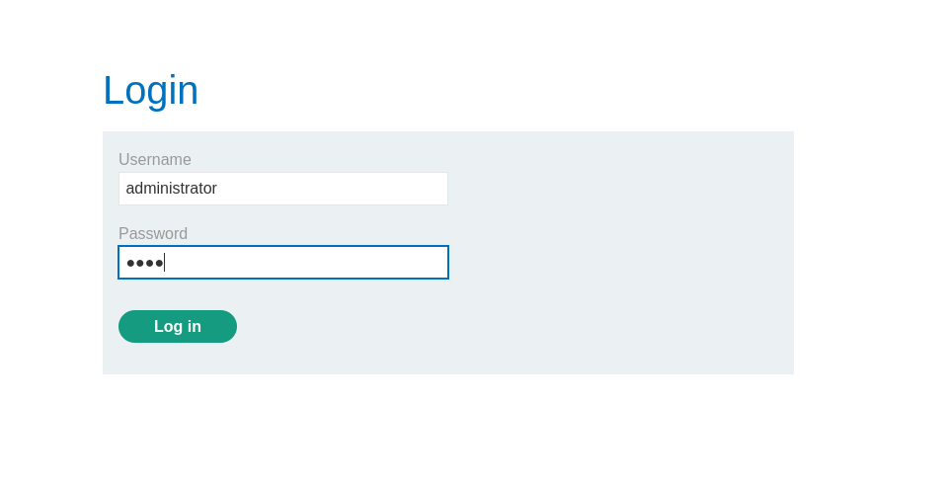

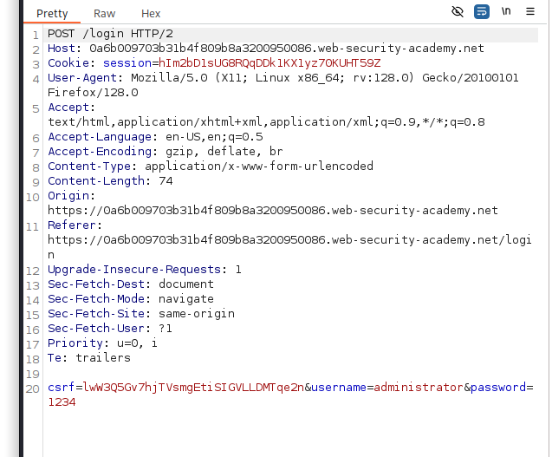

Step 2: Probing for SQL Injection Append a single quote (') to the username parameter value and submit the request. If the server returns a "500 Internal Server Error," it confirms that the single quote has broken the SQL syntax, indicating that the input is being processed directly by the database.

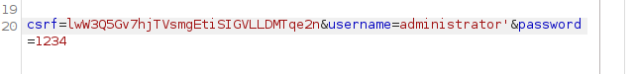

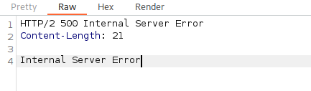
Step 3: Implementing the Login Bypass Payload The application executes a background query similar to: SELECT * FROM users WHERE username = 'USER' AND password = 'PASSWORD'
To bypass this, modify the username parameter to administrator'--. The -- (comment) sequence instructs the database to ignore the rest of the query, effectively removing the AND password = ... condition.

Step 4: Verifying Unauthorized Access Submit the modified request. Observe the response for a 302 Found status code and a Location: /my-account header. Refresh the browser to confirm that you are logged in as the administrator and can view the account management page.

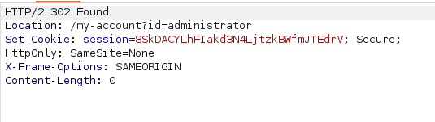

Lab#3 - SQL injection attack, querying the database type and version on Oracle

4.1. Laboratory Information
The application's product category filter is vulnerable to SQL injection. Because the underlying database is Oracle, every SELECT statement must include a FROM clause, and the system table v$version must be queried to retrieve version information. This vulnerability allows an attacker to use UNION-based attacks to bypass the intended query results and exfiltrate system-level data, such as the database type and version.

4.2. Solution Steps

Step 1: Intercepting the Request Navigate to the application and select a specific product category (e.g., Gifts). Use Burp Suite to intercept the resulting GET /filter?category=... request and send it to the Repeater tab for manual manipulation.

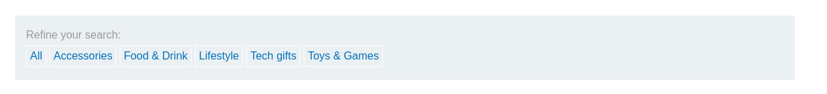

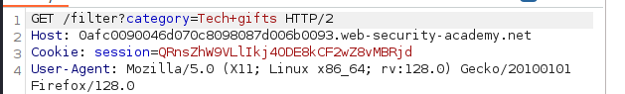

Step 2: Determining Column Count and Data Types In Oracle databases, the DUAL table is used for queries that do not require a physical table. To verify the number of columns and ensure they support text data, the following payload was injected into the category parameter:

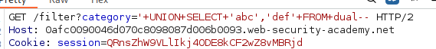

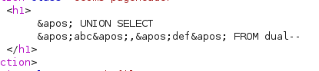

Step 3: Querying the Database Version With the column structure confirmed, the final objective was to retrieve the Oracle database version. This information is stored in the BANNER column of the v$version system table. The following payload was used:

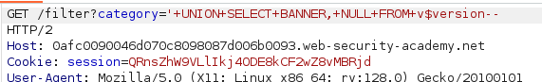

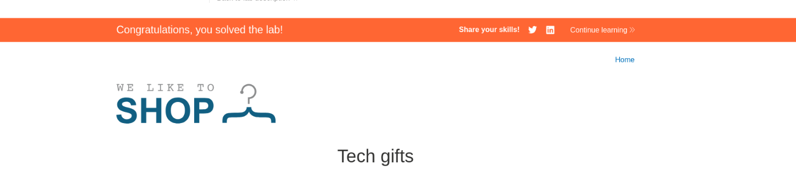

Lab#4 - SQL injection attack, querying the database type and version on MySQL and Microsoft

5.1. Laboratory Information

The application's product category filter contains a SQL injection vulnerability that allows for UNION-based attacks. The backend database is identified as either MySQL or Microsoft SQL Server. This vulnerability is significant because it enables an attacker to manipulate the original SQL query to retrieve sensitive system information, such as the database version. By appending a second query to the legitimate one, an attacker can bypass security controls and display internal database metadata directly within the application's user interface.

5.2. Solution Steps
Step 1: Intercepting and analyzing the request The process begins by navigating to the application's product page and selecting a category to generate a filtered web request. Burp Suite is used to intercept this HTTP GET request, which is then sent to the Repeater tab. This allows the researcher to manually modify the category parameter and observe how the server responds to various SQL injection payloads.

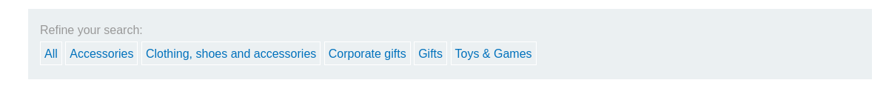
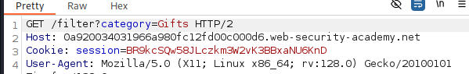

Step 2: Determining column count and data types The researcher must identify the number of columns returned by the original query to ensure the UNION attack is successful. By injecting the payload '+UNION+SELECT+'abc','def'# into the category parameter, the researcher tests for two columns. The hash symbol (#) is used to comment out the rest of the SQL query, which is a requirement for MySQL. The successful display of "abc" and "def" on the page confirms that there are two columns and both are compatible with string data.

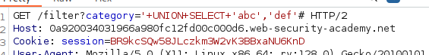

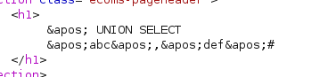
Step 3: Extracting the database version After confirming the query structure, the final step is to retrieve the database version string. In MySQL and Microsoft SQL Server, this is achieved by querying the @@version global variable. The researcher injects the payload '+UNION+SELECT+@@version,+NULL# into the category parameter and submits the request. The application renders the database version information on the screen, successfully fulfilling the lab requirements. Final verification is done by refreshing the browser to confirm the laboratory is solved.

